Use the below code and implement our CICD stages.
- Source Code: https://github.com/betawins/hiring-app.git
  - Repository contains the application code for the hiring app.
- Create one Declarative pipeline job
- Create one Scripted pipeline job
- Create one multi stage pipeline job
- Create one parallel stage pipeline job

1)Jenkins Official Documentation

Repository: [https://github.com/betawins/hiring-app.git](https://github.com/betawins/hiring-app.git)
Application Type: Java Maven Web Application (.war)
Prerequisites & Global Tool Setup
Configure the required Maven version in Jenkins so builds resolve consistently across both the controller and dynamic agents:
- Navigate to Manage Jenkins → Tools → Maven.
- Click Add Maven.
- Set Name to: Maven-3.9.6
- Select Install automatically and set the version to 3.9.6.
- Click Save.
1. Declarative Pipeline Job
A structured Declarative pipeline with sequential stages, workspace cleanup, and artifact publishing.
Pipeline Configuration
- In Jenkins, select New Item → Enter name (e.g., hiring-app-declarative) → Select Pipeline → Click OK.
- Scroll to the Pipeline script section and add the following code:

pipeline {
agent any

tools {
maven 'Maven-3.9.6'
}

environment {
JAVA_HOME = '/usr/lib/jvm/java-21-amazon-corretto.x86_64'
PATH = "$env.JAVA_{H}OME/bin:${env.PATH}"
APP_NAME = 'hiring-app'
GIT_URL = 'https://github.com/betawins/hiring-app.git'
}

options {
timestamps()
buildDiscarder(logRotator(numToKeepStr: '10'))
disableConcurrentBuilds()
}

stages {
stage('Checkout') {
steps {
git branch: 'main', url: "${env.GIT_URL}"
}
}

stage('Verify Environment') {
steps {
sh 'echo "JAVA_HOME=$JAVA_HOME"'
sh 'java -version'
sh 'mvn -version'
}
}

stage('Build') {
steps {
sh 'mvn clean package -DskipTests'
}
}

stage('Test') {
steps {
sh 'mvn test'
}
post {
always {
junit testResults: 'target/surefire-reports/*.xml', allowEmptyResults: true
}
}
}

stage('Archive Artifact') {
steps {
archiveArtifacts artifacts: 'target/*.war', fingerprint: true
}
}
}

post {
success { echo "✅ ${env.APP_NAME} Declarative build SUCCESS" }
failure { echo "❌ ${env.APP_NAME} Declarative build FAILED" }
always { cleanWs() }
}
}

- Click Save and trigger with Build Now.

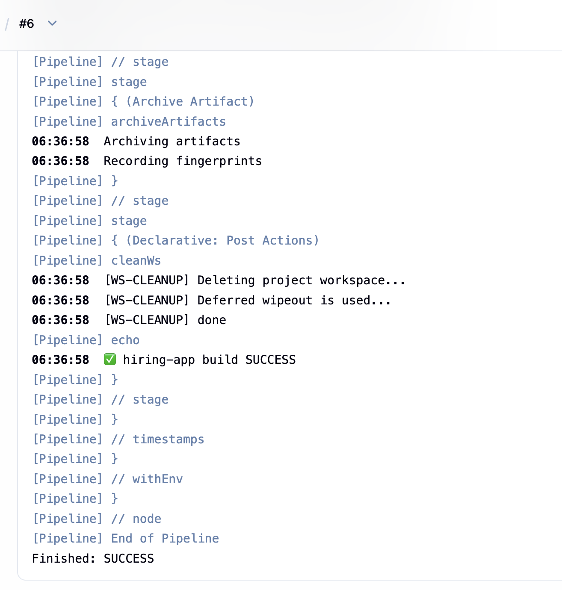

2)Scripted Pipeline Job
A Groovy-based Scripted pipeline using dynamic tool resolution and robust try-catch-finally error handling.
Pipeline Configuration
- Select New Item → Name it hiring-app-scripted → Select Pipeline → Click OK.
- Add the following code into the script editor:

node {
def mvnHome = tool 'Maven-3.9.6'
def JAVA_HOME = '/usr/lib/jvm/java-21-amazon-corretto.x86_64'
def GIT_URL = 'https://github.com/betawins/hiring-app.git'
def APP_NAME = 'hiring-app'

withEnv([
"JAVA_HOME=${JAVA_HOME}",
"PATH=$mvnHome/bin:${JAVA_HOME}/bin:${env.PATH}"
]) {
timestamps {
try {
stage('Checkout') {
git branch: 'main', url: GIT_URL
}

stage('Verify Environment') {
sh 'echo "JAVA_HOME=$JAVA_HOME"'
sh 'java -version'
sh 'mvn -version'
}

stage('Build') {
sh 'mvn clean package -DskipTests'
}

stage('Test') {
try {
sh 'mvn test'
} finally {
junit testResults: 'target/surefire-reports/*.xml', allowEmptyResults: true
}
}

stage('Archive Artifact') {
archiveArtifacts artifacts: 'target/*.war', fingerprint: true
}

echo "✅ ${APP_NAME} Scripted build SUCCESS"
} catch (Exception e) {
echo "❌ ${APP_NAME} Scripted build FAILED: ${e.getMessage()}"
currentBuild.result = 'FAILURE'
throw e
} finally {
cleanWs()
}
}
}
}

- Click Save and click Build Now.

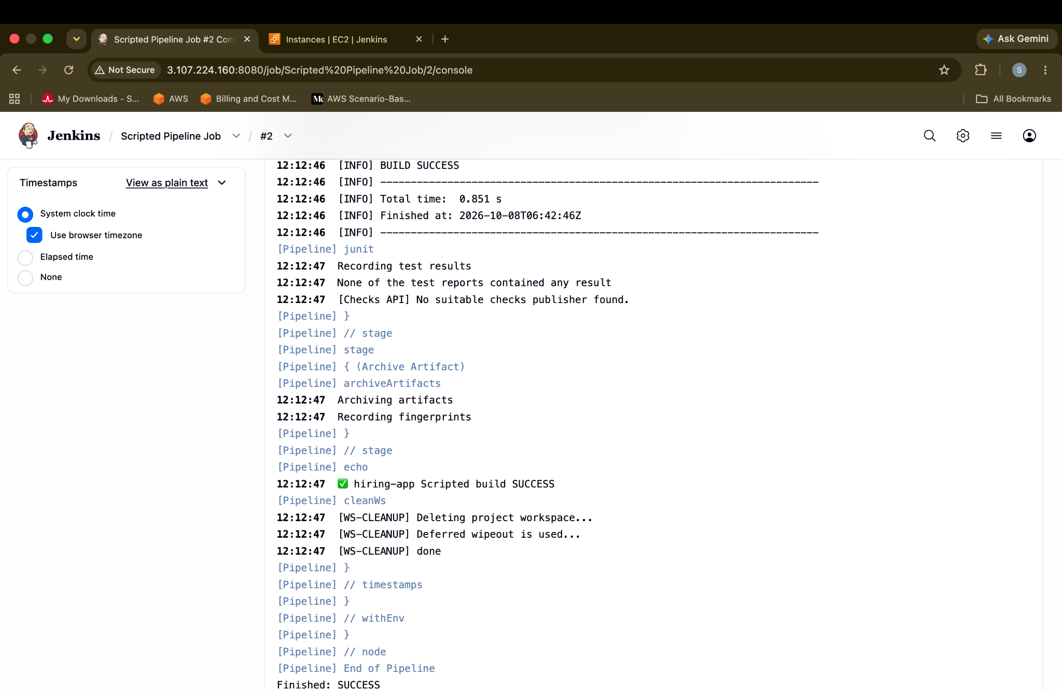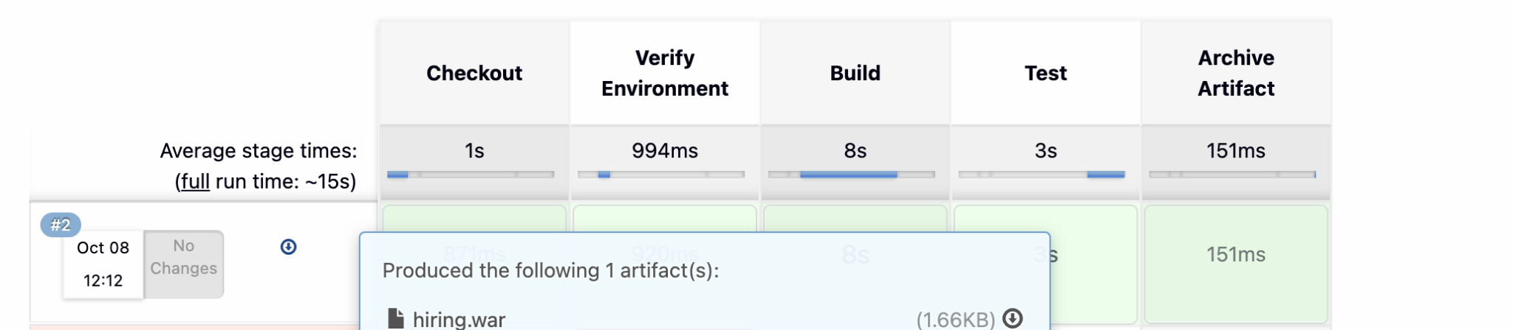

3)Multi-Stage Pipeline Job
Breaks the delivery process down into granular lifecycle phases: checkout, verification, compilation, unit testing, packaging, and artifact inspection.
Pipeline Configuration
- Select New Item → Name it hiring-app-multistage → Select Pipeline → Click OK.
- Paste the following script:

pipeline {
agent any

tools {
maven 'Maven-3.9.6'
}

environment {
JAVA_HOME = '/usr/lib/jvm/java-21-amazon-corretto.x86_64'
PATH = "$env.JAVA_{H}OME/bin:${env.PATH}"
APP_NAME = 'hiring-app'
GIT_URL = 'https://github.com/betawins/hiring-app.git'
}

options {
timestamps()
buildDiscarder(logRotator(numToKeepStr: '10'))
disableConcurrentBuilds()
}

stages {
stage('1. Checkout') {
steps {
git branch: 'main', url: "${env.GIT_URL}"
}
}

stage('2. Environment Verification') {
steps {
sh 'echo "JAVA_HOME=$JAVA_HOME"'
sh 'java -version'
sh 'mvn -version'
}
}

stage('3. Compile') {
steps {
sh 'mvn clean compile'
}
}

stage('4. Unit Test') {
steps {
sh 'mvn test'
}
post {
always {
junit testResults: 'target/surefire-reports/*.xml', allowEmptyResults: true
}
}
}

stage('5. Package (WAR)') {
steps {
sh 'mvn package -DskipTests'
archiveArtifacts artifacts: 'target/*.war', fingerprint: true
}
}

stage('6. Pre-Deployment Staging') {
steps {
echo "Validating created WAR package..."
sh 'ls -lh target/*.war'
}
}
}

post {
success { echo "✅ ${env.APP_NAME} Multi-Stage build completed successfully." }
failure { echo "❌ ${env.APP_NAME} Multi-Stage build failed." }
always { cleanWs() }
}
}

- Click Save and run Build Now.

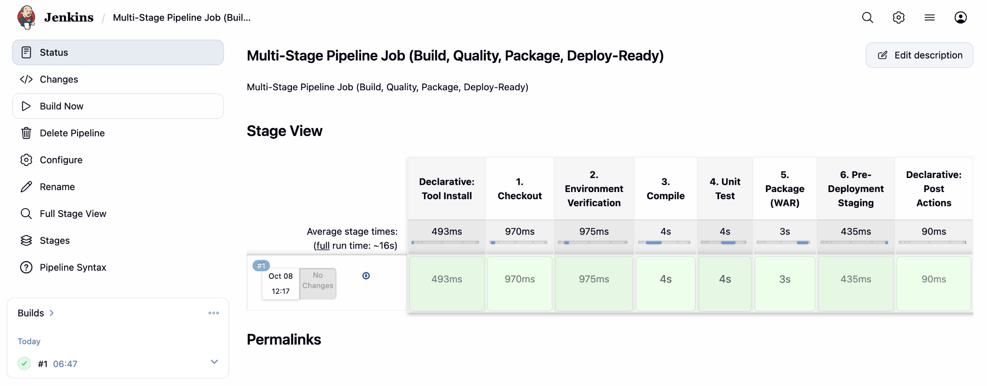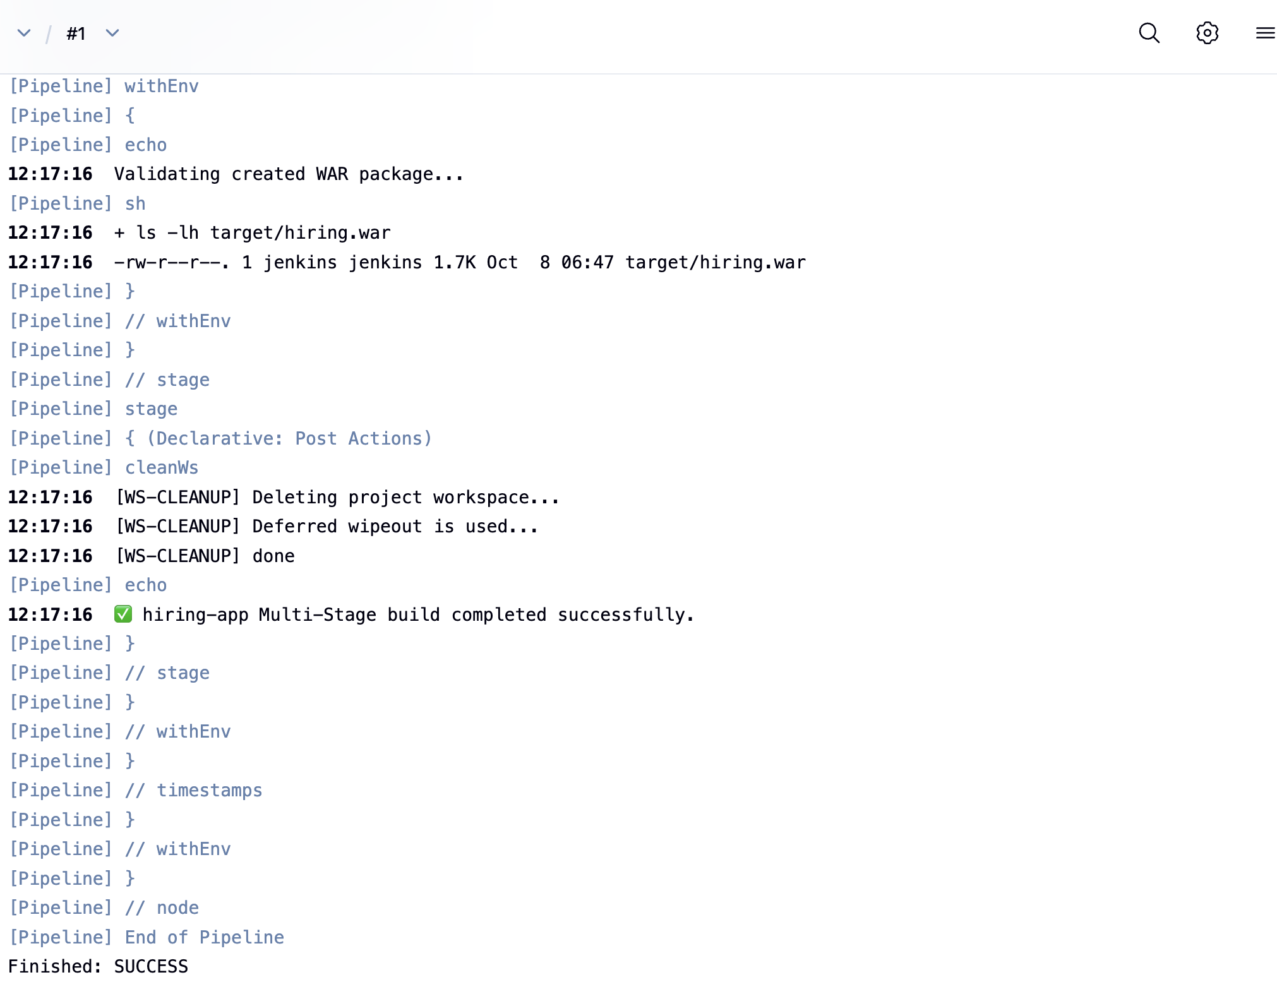

4)Parallel Stage Pipeline Job
Executes unit testing, dependency downloads, and validation steps concurrently after an initial compilation stage.
Pipeline Configuration
- Select New Item → Name it hiring-app-parallel → Select Pipeline → Click OK.
- Paste the following script:

pipeline {
agent any

tools {
maven 'Maven-3.9.6'
}

environment {
JAVA_HOME = '/usr/lib/jvm/java-21-amazon-corretto.x86_64'
PATH = "$env.JAVA_{H}OME/bin:${env.PATH}"
APP_NAME = 'hiring-app'
GIT_URL = 'https://github.com/betawins/hiring-app.git'
}

options {
timestamps()
buildDiscarder(logRotator(numToKeepStr: '10'))
disableConcurrentBuilds()
}

stages {
stage('Checkout & Verify') {
steps {
git branch: 'main', url: "${env.GIT_URL}"
sh 'echo "JAVA_HOME=$JAVA_HOME"'
sh 'java -version'
sh 'mvn -version'
}
}

stage('Compile') {
steps {
sh 'mvn clean compile'
}
}

stage('Parallel Validations') {
parallel {
stage('Unit Tests') {
steps {
sh 'mvn test'
}
post {
always {
junit testResults: 'target/surefire-reports/*.xml', allowEmptyResults: true
}
}
}

stage('Dependency Resolution') {
steps {
sh 'mvn dependency:resolve'
}
}

stage('Code Validation') {
steps {
sh 'mvn -B validate'
}
}
}
}

stage('Package Application') {
steps {
sh 'mvn package -DskipTests'
archiveArtifacts artifacts: 'target/*.war', fingerprint: true
}
}
}

post {
success { echo "✅ ${env.APP_NAME} Parallel Pipeline completed successfully." }
failure { echo "❌ ${env.APP_NAME} Parallel Pipeline failed." }
always { cleanWs() }
}
}

- Click Save and trigger with Build Now.

